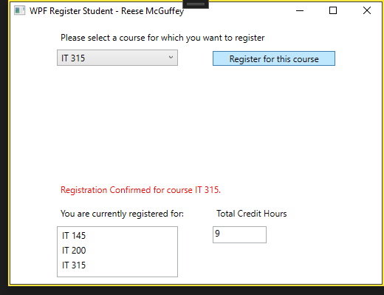

The intended user experience with no errors. The user must select in a list of courses the course they want to register for. Once the register button is clicked, it will add it to the list of currently registered courses and add the course’s credit hours to the total credit hours. There will also be a confirmation message letting the user know that the registration was successfully confirmed. Program terminates at the user's request.

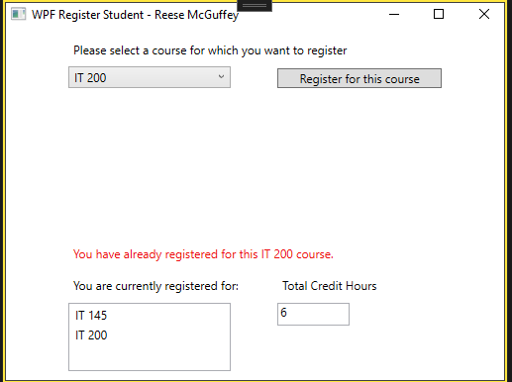

The user cannot register for a course they have already registered for. The program tells the user this with a message. The course is not added to the registered list and the total credit hours is not updated.

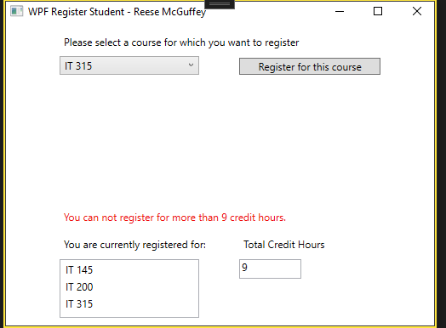

The user cannot register any more courses if the total credit hours is or exceeds nine (meaning the user can only register three courses). This error message takes priority over the message corresponding to registering an already existing course. The program tells the user this with a message. The course is not added to the registered list and the total credit hours is not updated.

MainWindow.xaml.cs:

(Note: I renamed the label that outputs status messages to “status”)

using System;

using System.Collections.Generic;

using System.Linq;

using System.Text;

using System.Threading.Tasks;

using System.Windows;

using System.Windows.Controls;

using System.Windows.Data;

using System.Windows.Documents;

using System.Windows.Input;

using System.Windows.Media;

using System.Windows.Media.Imaging;

using System.Windows.Navigation;

using System.Windows.Shapes;

namespace WPFRegisterStudent

{

/// <summary>

/// Interaction logic for MainWindow.xaml

/// </summary>

public partial class MainWindow : Window

{

Course choice;

int credits = 0;

public MainWindow()

{

InitializeComponent();

}

private void Window_Loaded(object sender, RoutedEventArgs e)

{

Course course1 = new Course("IT 145");

Course course2 = new Course("IT 200");

Course course3 = new Course("IT 201");

Course course4 = new Course("IT 270");

Course course5 = new Course("IT 315");

Course course6 = new Course("IT 328");

Course course7 = new Course("IT 330");

this.comboBox.Items.Add(course1);

this.comboBox.Items.Add(course2);

this.comboBox.Items.Add(course3);

this.comboBox.Items.Add(course4);

this.comboBox.Items.Add(course5);

this.comboBox.Items.Add(course6);

this.comboBox.Items.Add(course7);

}

private void button_Click(object sender, RoutedEventArgs e)

{

choice = (Course)(this.comboBox.SelectedItem);

bool valid = true;

if (credits >= 9)

{

this.status.Content = ("You can not register for more than 9 credit hours.");

valid = false;

}

else if (choice.IsRegisteredAlready() == true)

{

this.status.Content = ("You have already registered for this " + choice.getName() + " course.");

valid = false;

}

if (valid == true)

{

this.status.Content = ("Registration Confirmed for course " + choice.getName() + ".");

choice.SetToRegistered();

this.listBox.Items.Add(choice);

credits += 3;

this.textBox.Text = credits.ToString();

}

}

}

}

Course.cs:

using System;

using System.Collections.Generic;

using System.Linq;

using System.Text;

using System.Threading.Tasks;

namespace WPFRegisterStudent

{

class Course

{

private string name = "";

private bool isRegisteredAlready = false;

public Course(string name)

{

this.name = name;

}

public void setName(string name)

{

this.name = name;

}

public string getName()

{

return name;

}

public bool IsRegisteredAlready()

{

return isRegisteredAlready;

}

public void SetToRegistered()

{

isRegisteredAlready = true;

}

public override string ToString()

{

return getName();

}

}

}